OASIS INFOBYTE

DATA ANALYTICS INTERNSHIP

PROJECT 3

UNVEILING THE ANDROID APP MARKET:
ANALYZING GOOGLE PLAY STORE DATA

Submitted By:
Krushna Bhuskute

Date:
June 2026

OBJECTIVE
The objective of this project is to analyze Google Play Store data and gain insights into the Android application market. The project focuses on data cleaning, category exploration, ratings analysis, installs analysis, pricing trends, and user sentiment analysis. Through exploratory data analysis and visualization techniques, meaningful patterns and trends are identified to better understand app performance and user behavior.

DATASET INFORMATION
Dataset Name: Google Play Store Dataset
Total Records: 9,659
Total Columns: 14
The dataset contains information related to Android applications available on the Google Play Store. Important attributes include application name, category, rating, reviews, size, installs, type, price, content rating, genres, and Android version compatibility.
Dataset Exploration
The dataset was loaded successfully using Python and Pandas. Initial exploration was performed using functions such as:
- head()
- shape
- columns
- info()
These functions helped understand the structure and characteristics of the dataset before analysis.
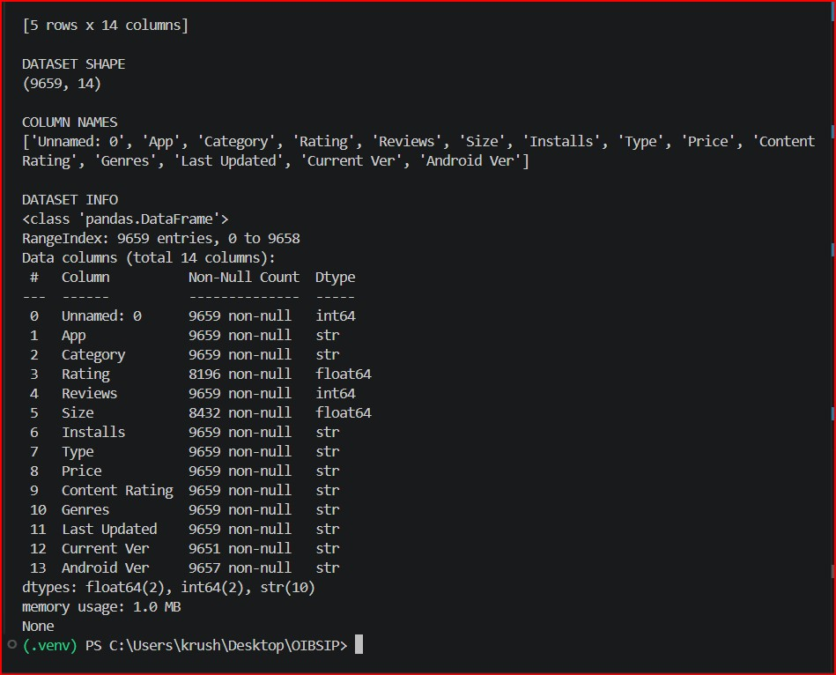
DATA CLEANING AND PREPROCESSING
Data cleaning is an important step in any data analytics project. The dataset was examined for missing values, duplicate records, and unnecessary columns.
Findings
- Rating column contained 1,463 missing values.
- Size column contained 1,227 missing values.
- Current Version column contained 8 missing values.
- Android Version column contained 2 missing values.
- Duplicate Records Found: 0.
An unnecessary column named Unnamed: 0 was removed from the dataset to improve data quality and readability.
The cleaning process ensured that the dataset was suitable for further analysis and visualization. 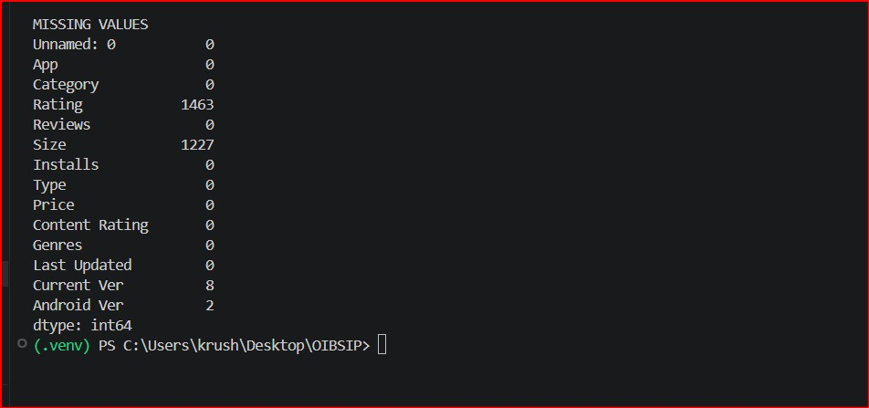
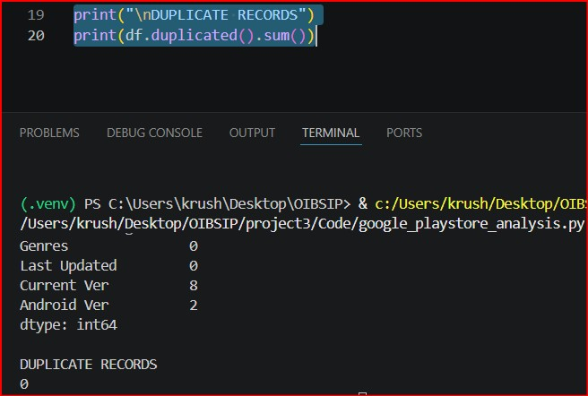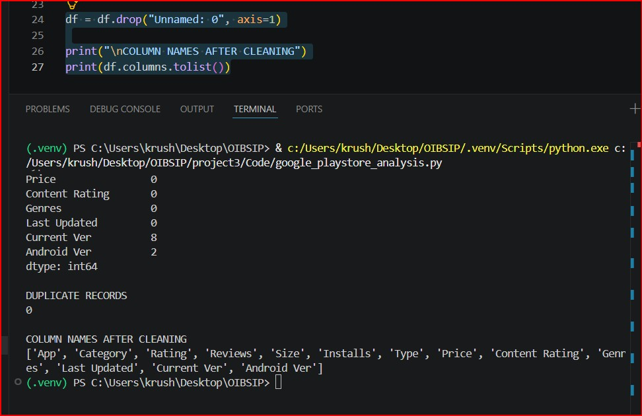

CATEGORY ANALYSIS
The distribution of applications across various categories was analyzed to understand the composition of the Google Play Store.
The analysis revealed that certain categories contain significantly more applications than others. Categories such as Family, Games, Tools, and Business have a large number of applications, indicating strong developer activity and user demand.
Understanding category distribution helps identify areas of market concentration and potential opportunities for application development. 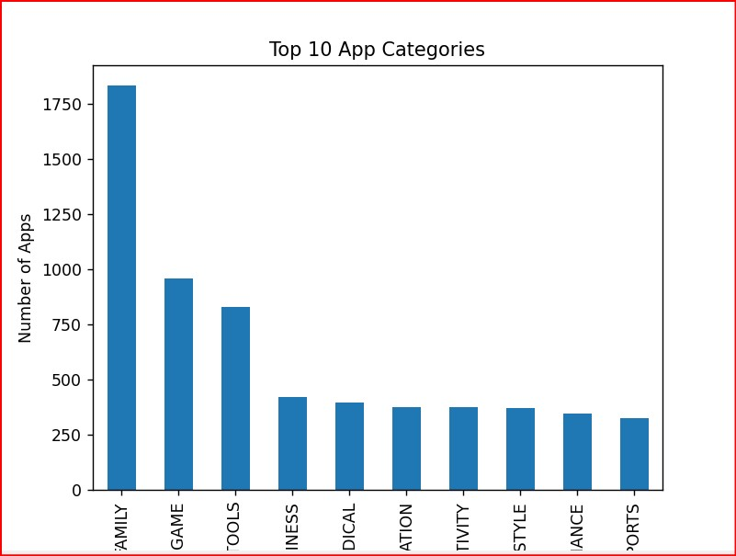

RATINGS ANALYSIS
Application ratings were analyzed to evaluate user satisfaction and overall application quality.
Descriptive statistics and rating distribution visualizations were generated to understand rating behavior across the Play Store.
Observation
Most applications have ratings concentrated in the higher range, suggesting that users generally provide positive feedback for applications they use. Highly rated applications often experience better visibility and user engagement. 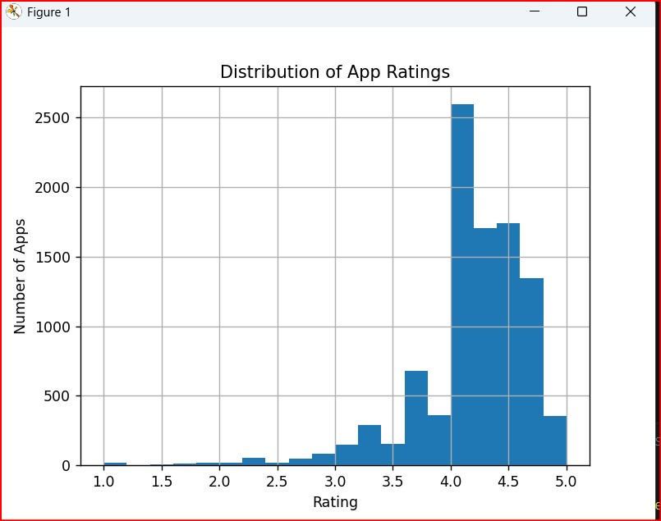
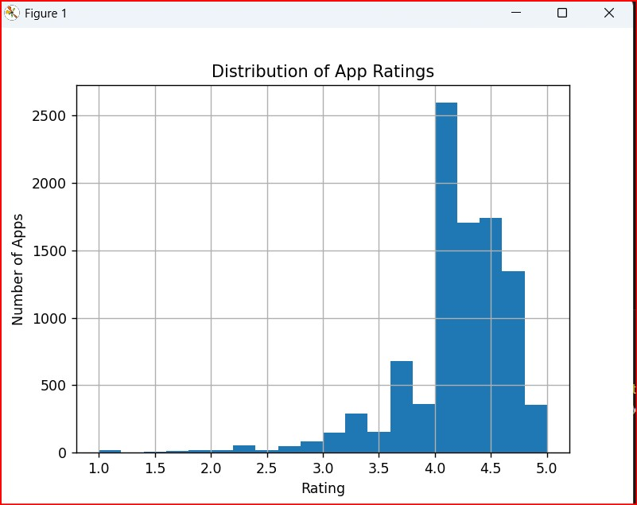

INSTALLS ANALYSIS
The installs metric was analyzed to understand application popularity and market reach.
Install values were cleaned and converted into numerical format for accurate analysis. Several applications achieved exceptionally high installation counts.
Observation
Applications such as YouTube, Instagram, Google Photos, Google Play Books, Google Play Games, and Subway Surfers recorded more than one billion installs, demonstrating their dominance within the Android ecosystem.
The install distribution shows that a small number of applications capture a significant portion of user attention and downloads.
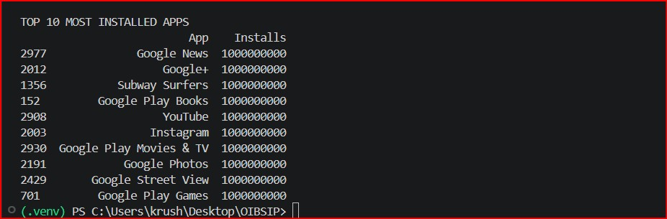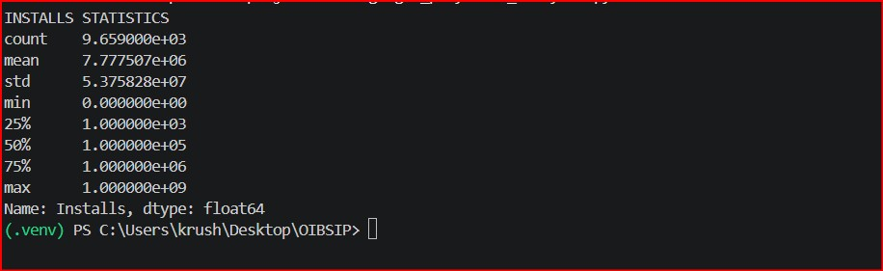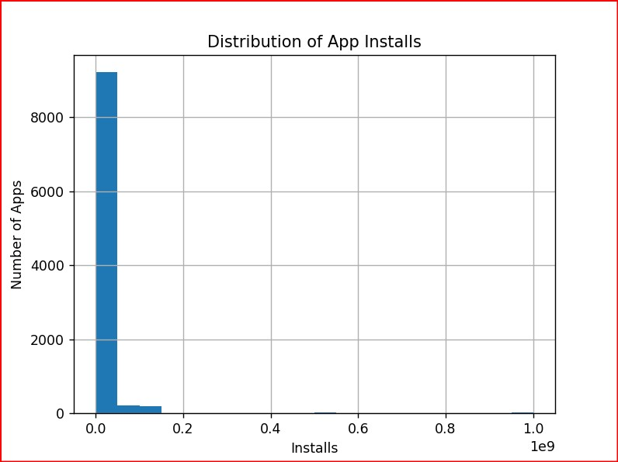

FREE VS PAID APPLICATION ANALYSIS
The Google Play Store contains both free and paid applications. The distribution of application types was analyzed to understand developer monetization strategies.
Observation
The analysis revealed that free applications significantly outnumber paid applications. Free applications attract a larger user base due to easy accessibility, while paid applications typically serve niche markets or premium audiences.
The dominance of free applications highlights the importance of advertisement-based and in-app purchase business models.

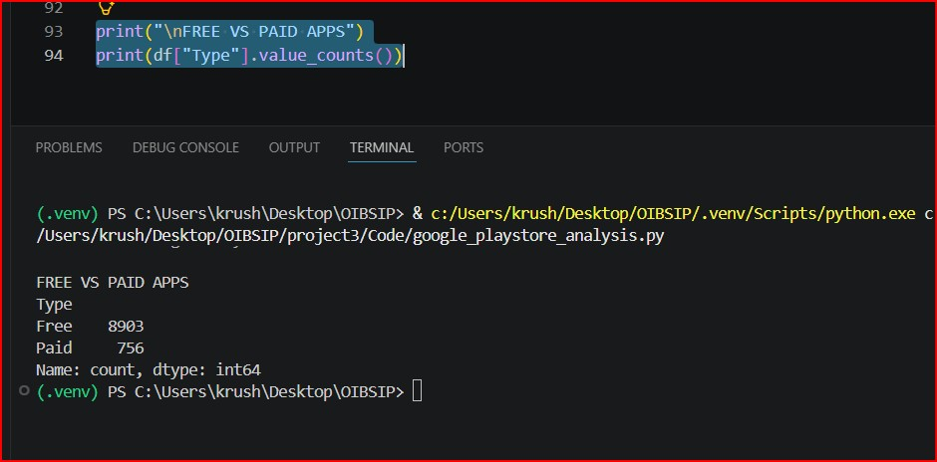

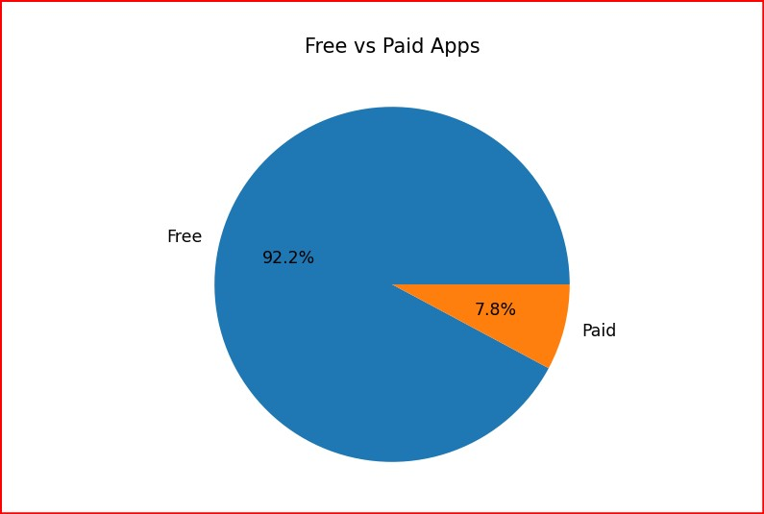
PRICE ANALYSIS
Pricing trends among paid applications were examined to understand the economic structure of the application market.
After cleaning and converting the Price column, descriptive analysis was performed on application pricing.
Observation
The most expensive application identified in the dataset was "I'm Rich - Trump Edition" priced at $400. Several other applications from the "I Am Rich" category were also among the highest-priced applications.
Despite the existence of extremely expensive applications, the majority of paid applications were priced at much lower values.

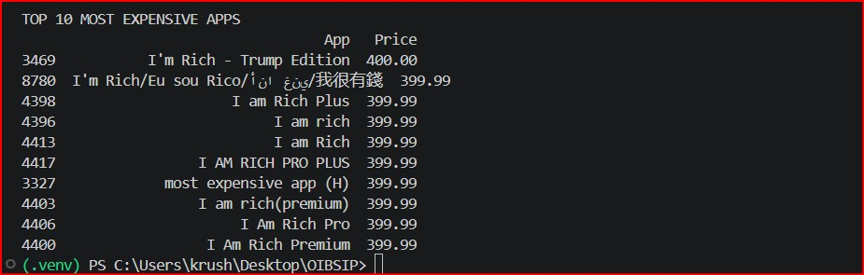
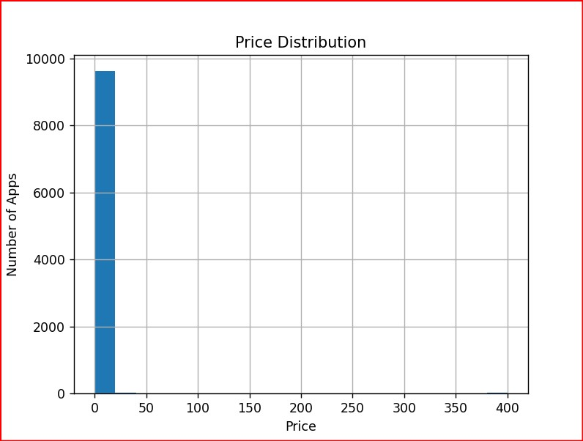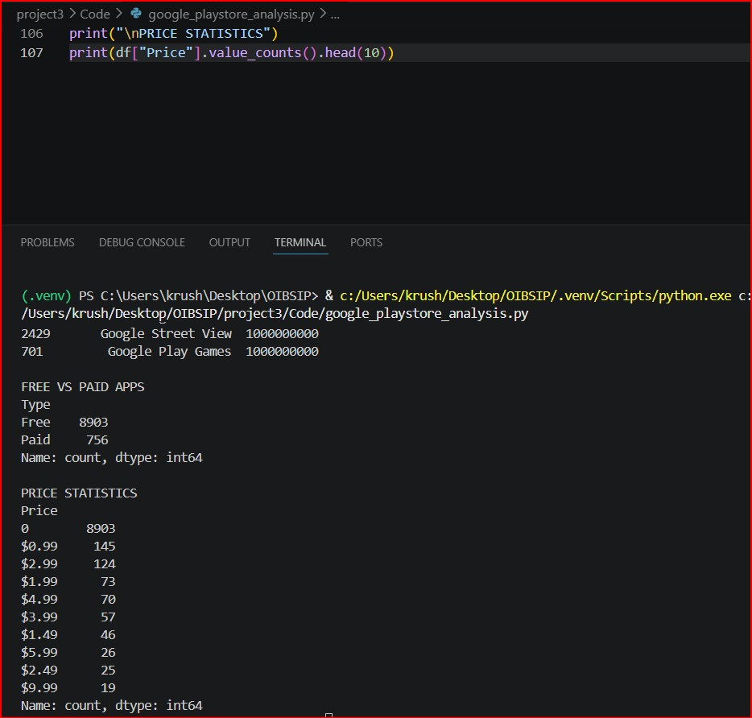

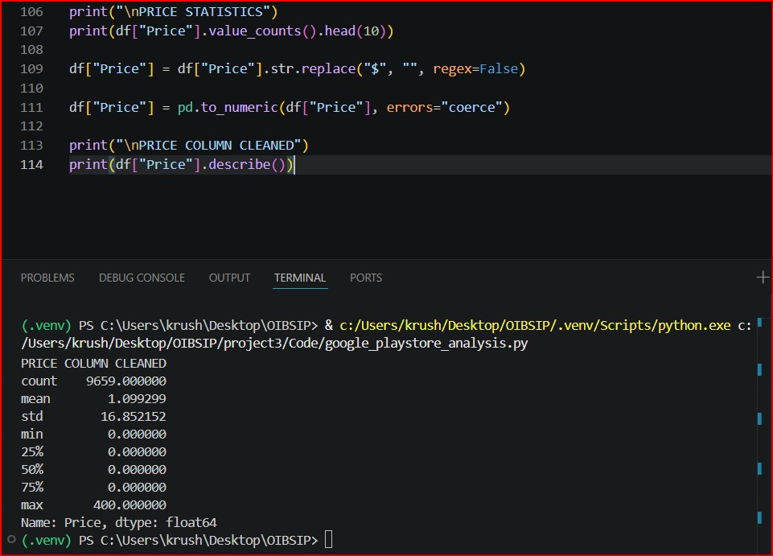
SENTIMENT ANALYSIS
User review data was analyzed to understand customer opinions and overall sentiment toward Android applications.
The review dataset contained more than 64,000 user reviews. Sentiment analysis categorized reviews into three groups:
- Positive
- Neutral
- Negative
Observation
Positive reviews represented the largest share of user feedback, indicating overall user satisfaction with many applications available on the platform. Neutral and negative reviews provided additional insight into areas where users experienced issues or expressed concerns.
Sentiment analysis plays an important role in understanding customer perception and improving application quality.

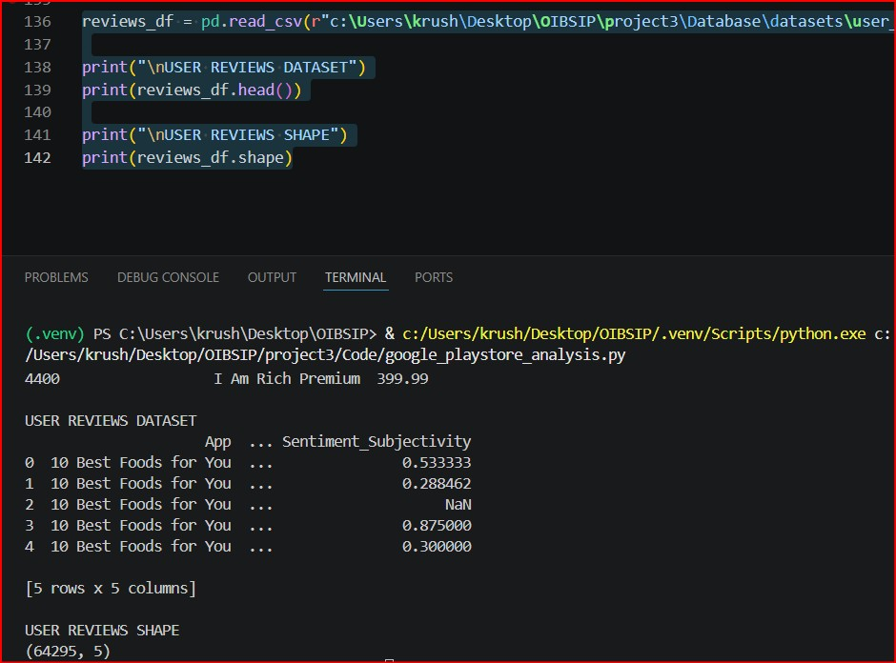
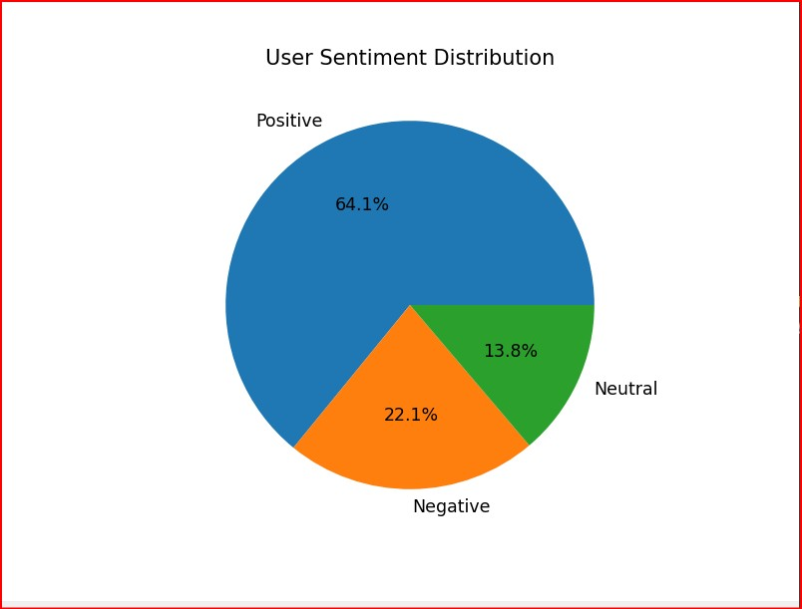
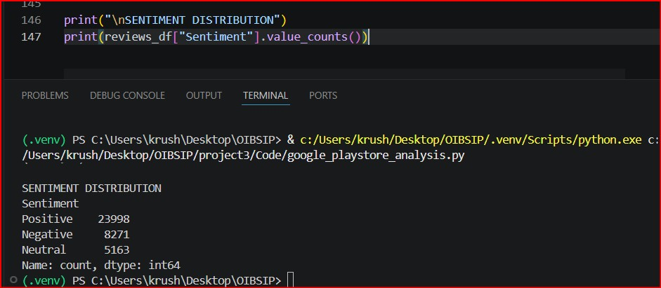
CONCLUSION
This project successfully analyzed Google Play Store data using data analytics and visualization techniques. Through data cleaning, category exploration, ratings analysis, installs analysis, pricing analysis, and sentiment analysis, valuable insights into the Android application ecosystem were obtained.
The study highlighted the dominance of free applications, the popularity of major Google products, the presence of highly rated applications, and the generally positive sentiment expressed by users.
The project enhanced practical skills in Python, Pandas, data cleaning, exploratory data analysis, visualization, and interpretation of real-world datasets. This analysis demonstrates how data-driven approaches can be used to understand market trends and user behavior in the mobile application industry.

